**Basic**

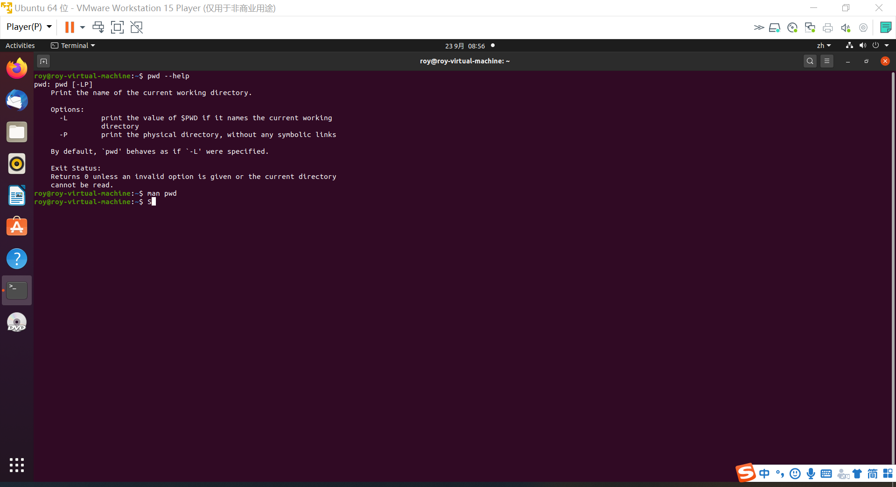

**Command: pwd – help**

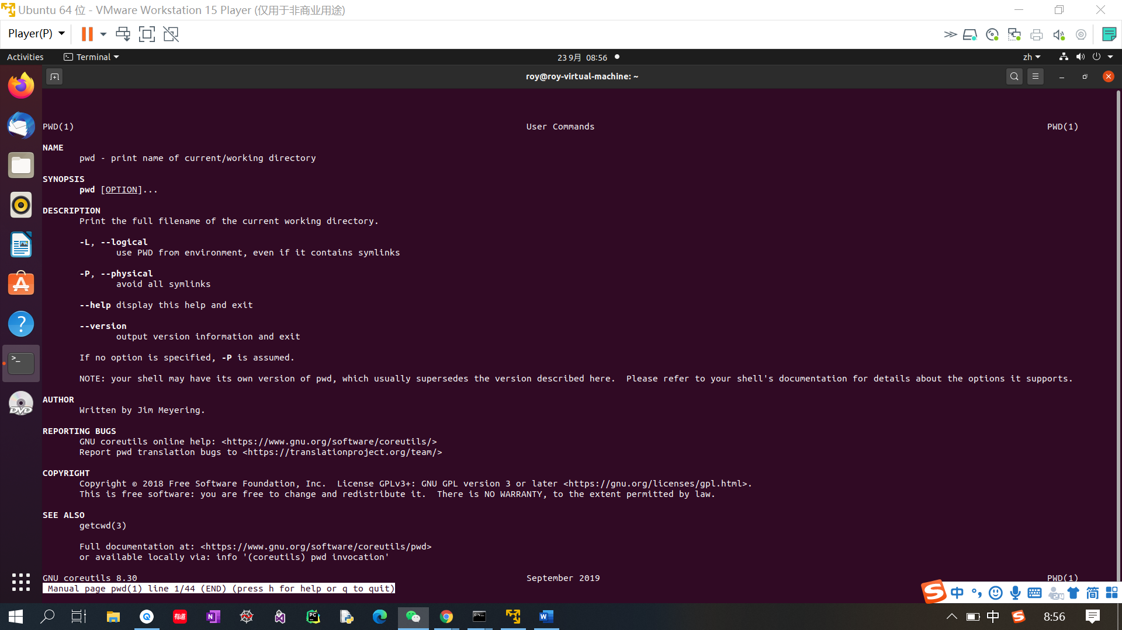

**Command: man pwd**

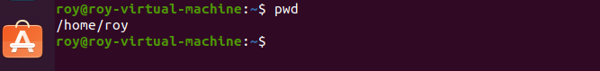

**Command: pwd, to print the current working directory.**



**Command: ls, list all the directories in the current working directory.**



**Command: ls -a, list all files**

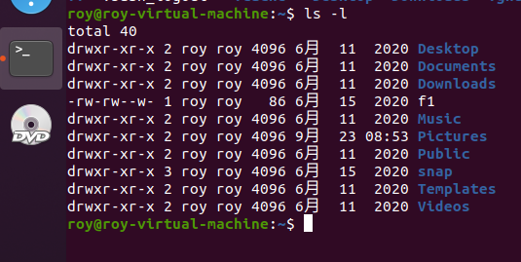

**Command: ls -l, long list of all the directories.**

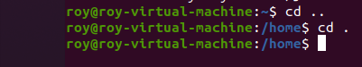

**Command: cd .. cd. Change directory to the parent directory and change directory to the current directory.**

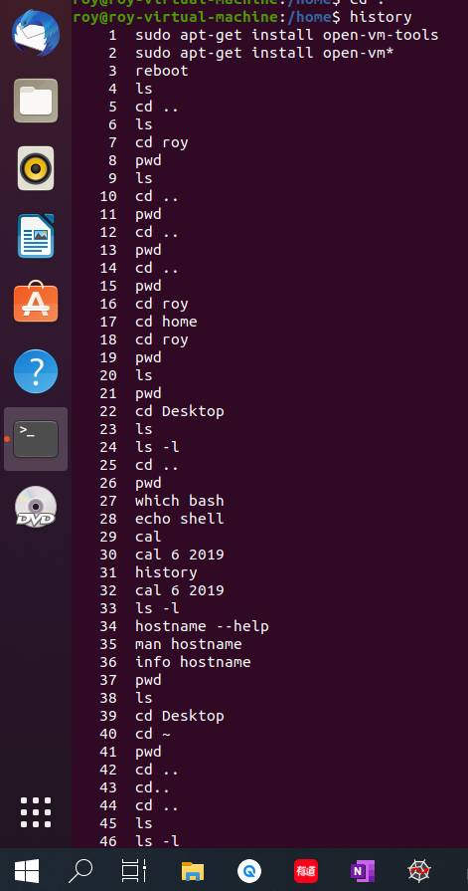

**Command: history, list all the history commands.**



**Command: echo, to print out something on the terminal.**

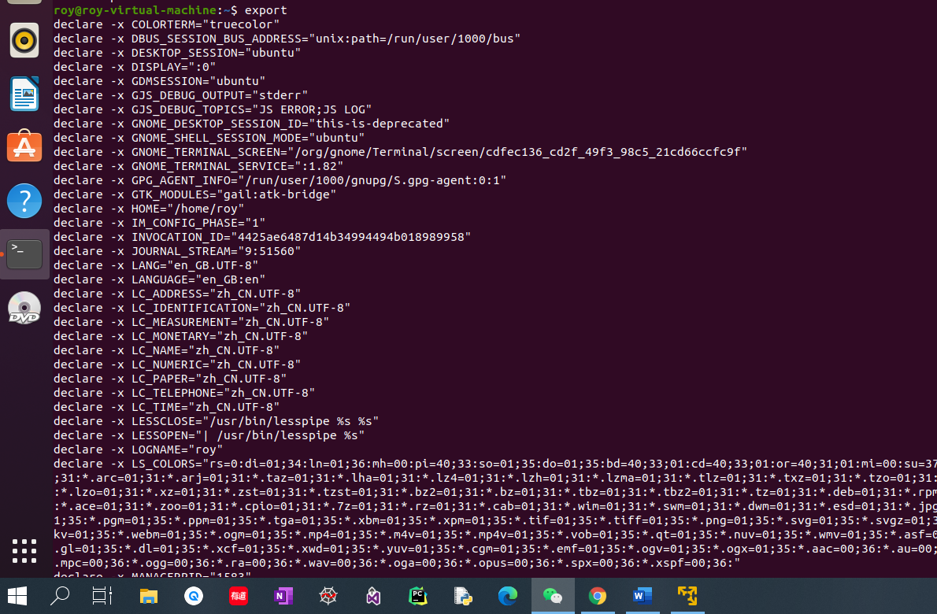

**Command: export, show all variables**

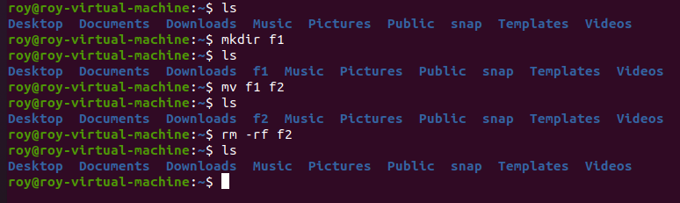

**Command: mkdir, mv, rm -rf; First make a directory named “f1”, and then rename directory “f1” to “f2”. Finally, remove directory “f2” recursively and forcedly.**

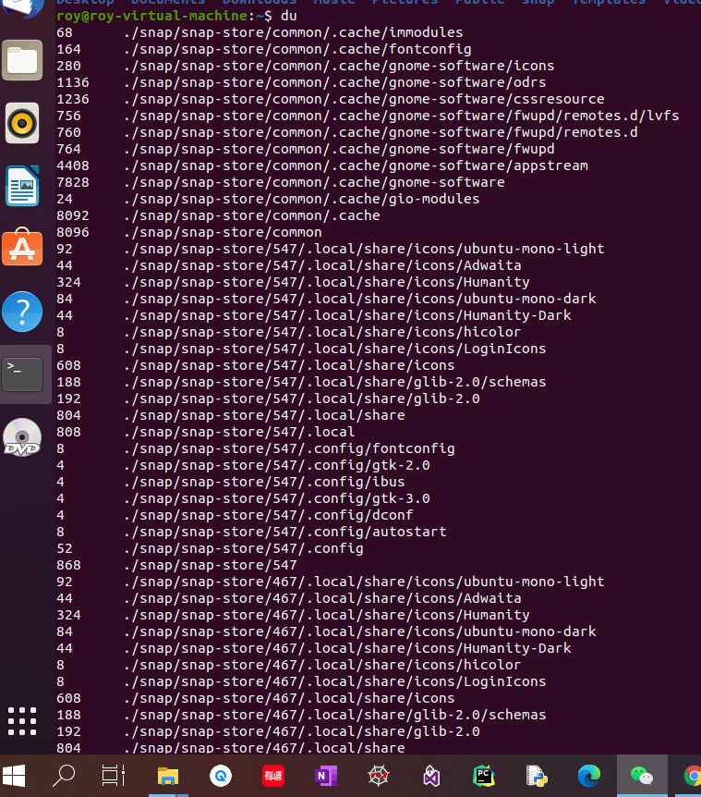

**Command: du, give the disk usage descriptions**

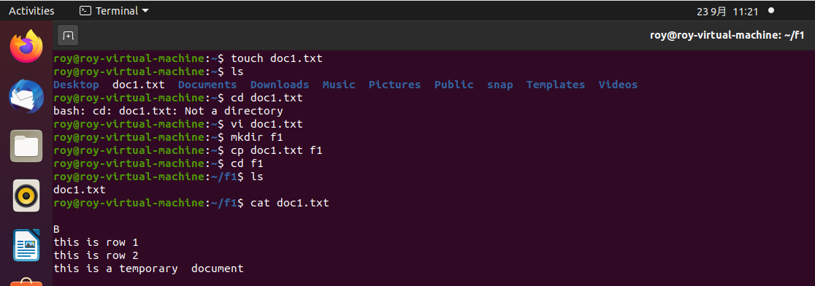

**Command: touch, vi, cp, cat; First, create a .txt file by command touch. Then, enter insert mode to modify the .txt file by command vi (filename). Next, copy the .txt file from the current directory to the directory “f1”. Finally, display the contents of the file by command cat (filename).**

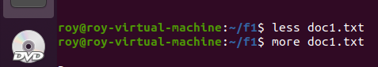

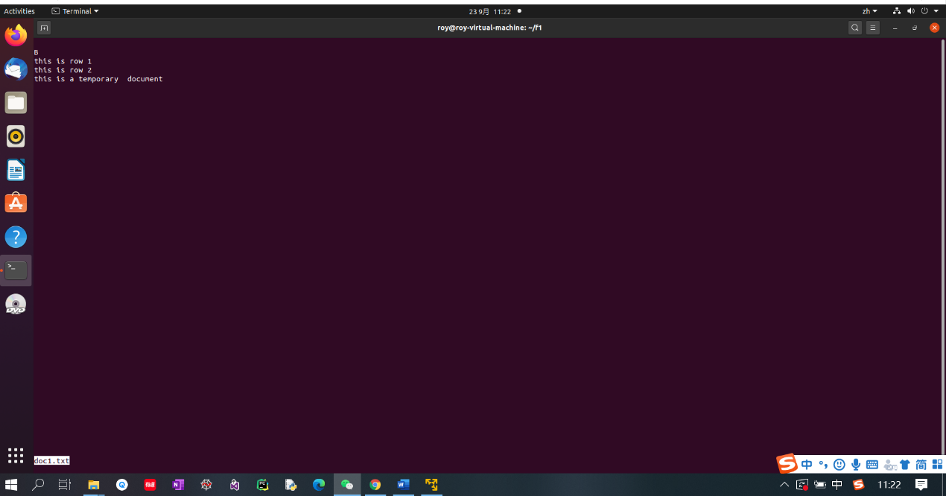

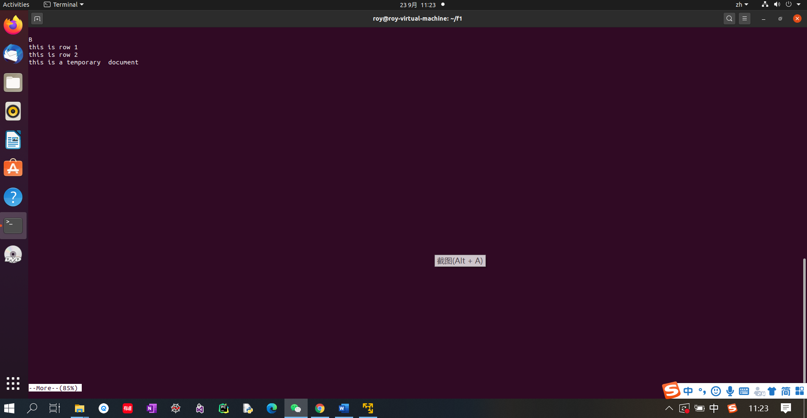

**Command: less, more; interactive display contents of file.**

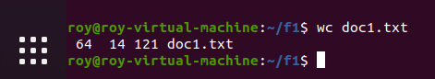

**Command: wc, print newline, word, and byte counts for each file.**



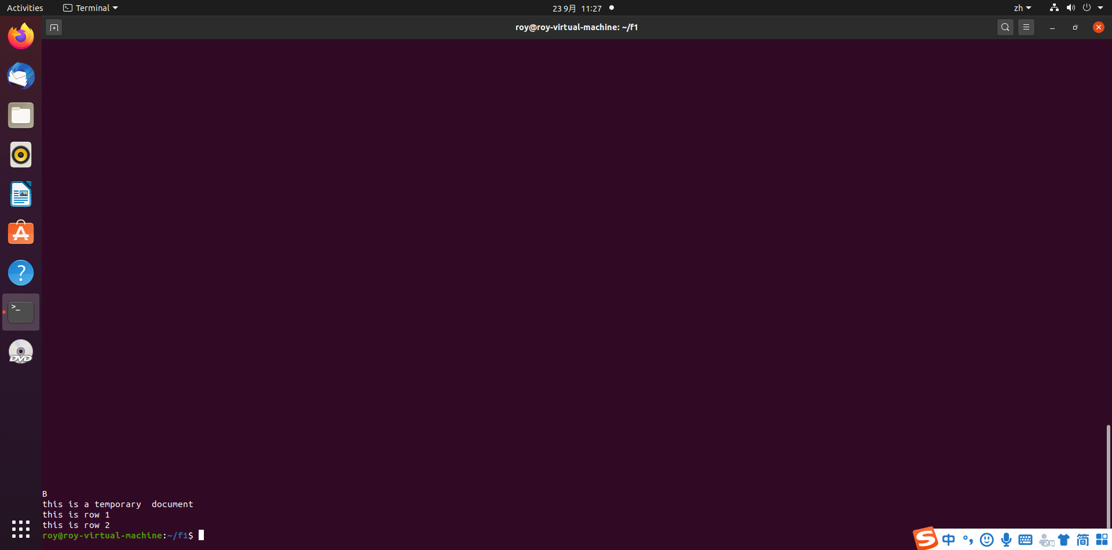

**Command: sort, sort lines of text files.**

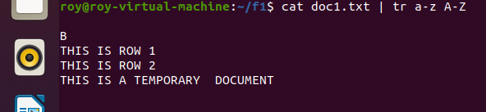

**Command: tr |, translate character from the lower case to upper case. Pipe the contents of the .txt file to the tr command.**

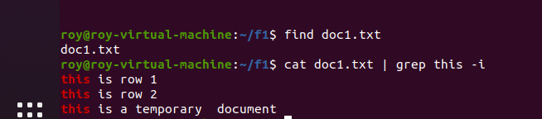

**Command: find, grep, search for files in a directory hierarchy. Print lines matching a RE pattern (includes this without consider the cases)**

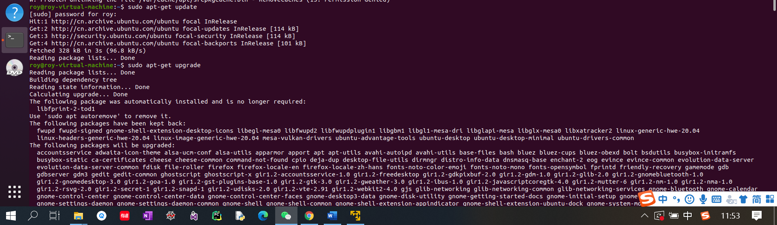

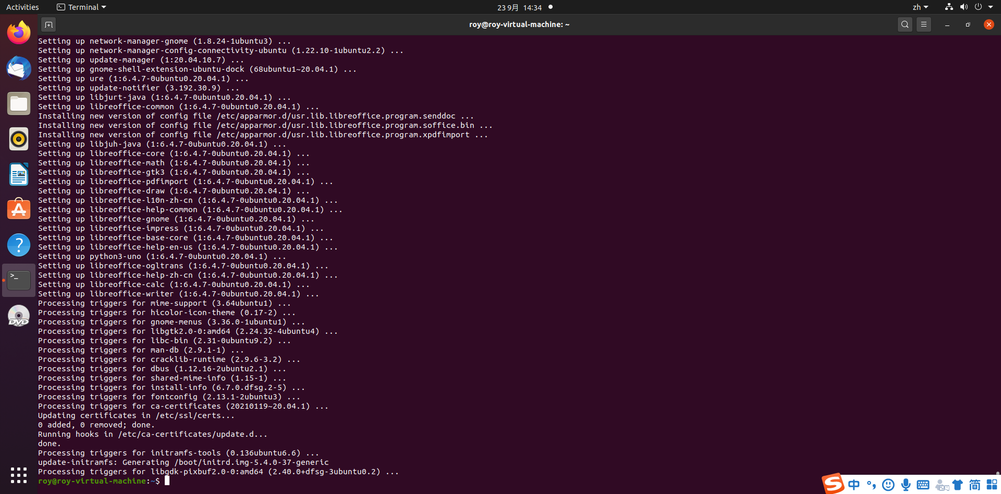

**Command: sudo ape-get update, update system software in a controller mode**

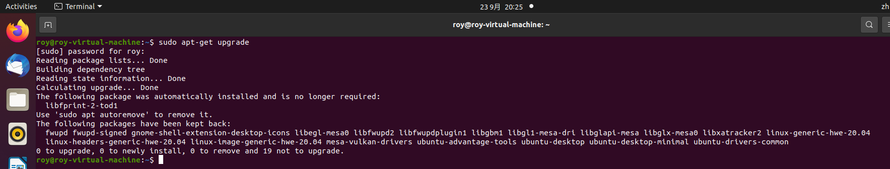

**Command: sudo ape-get upgrade, upgrade system in a controller mode**

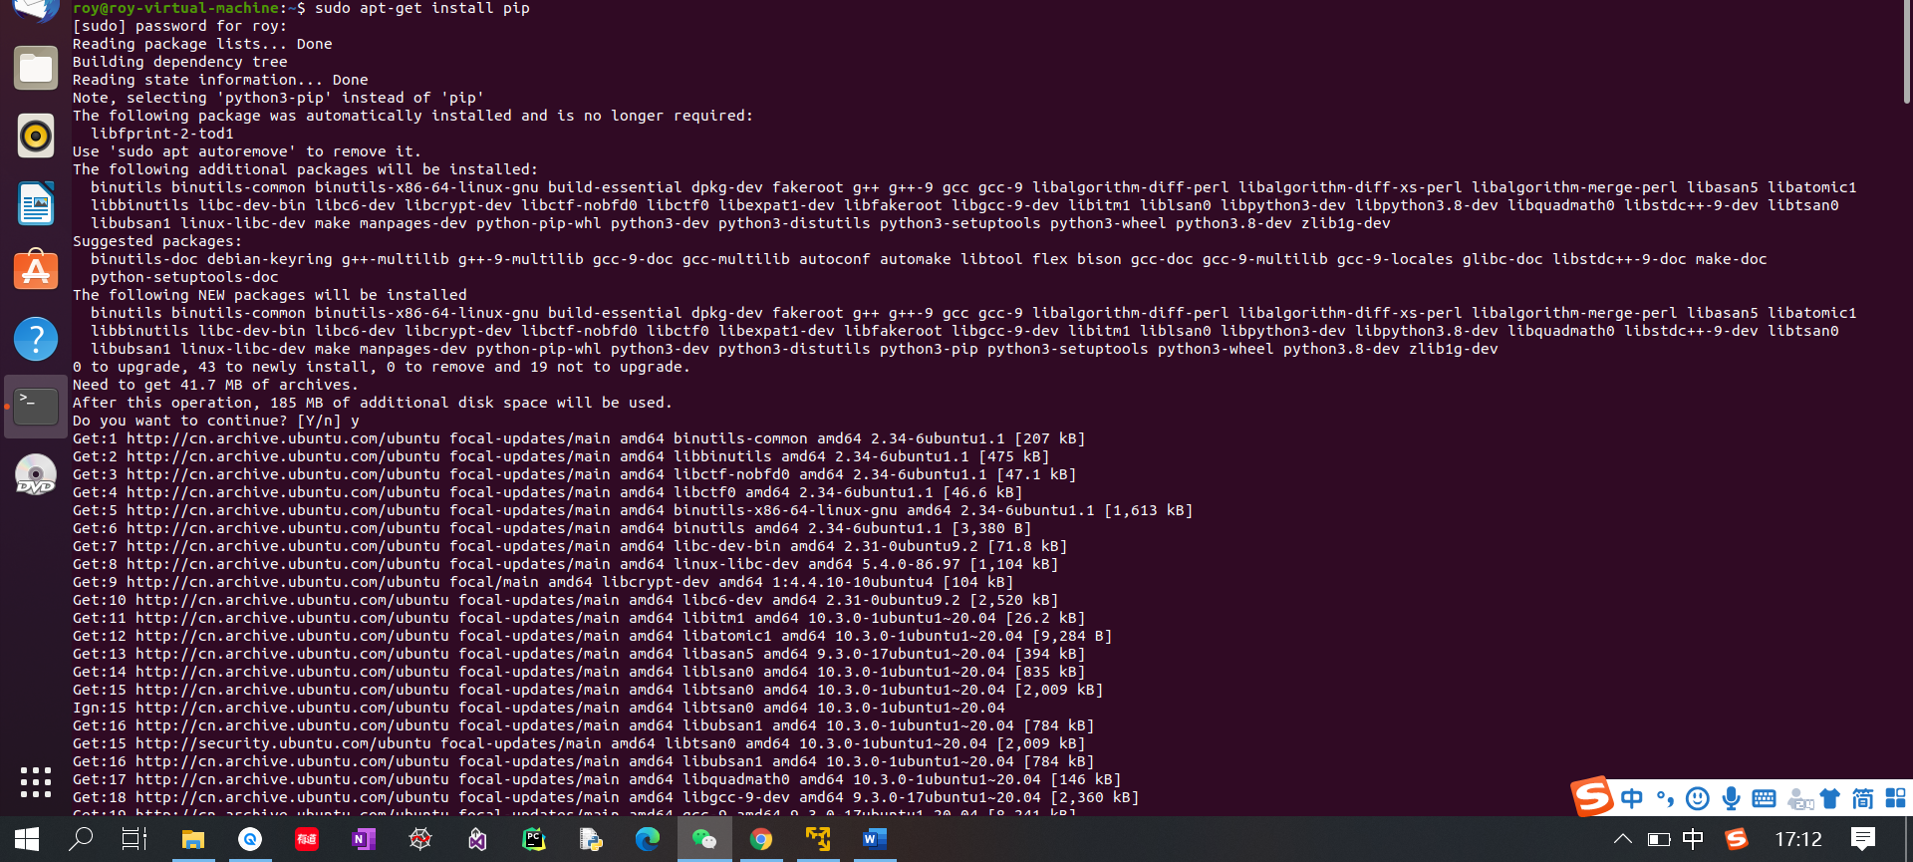

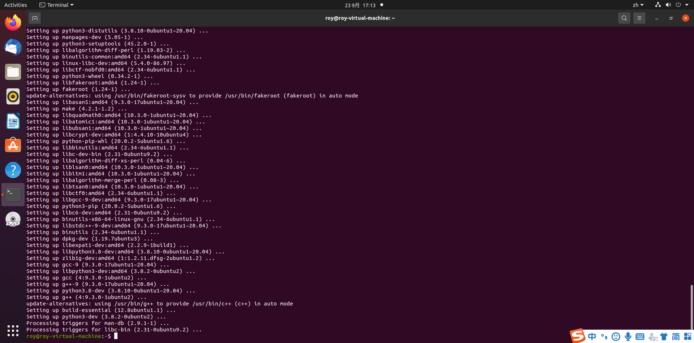

**Command: sudo ape-get install pip, install software “pip” in a controller mode**

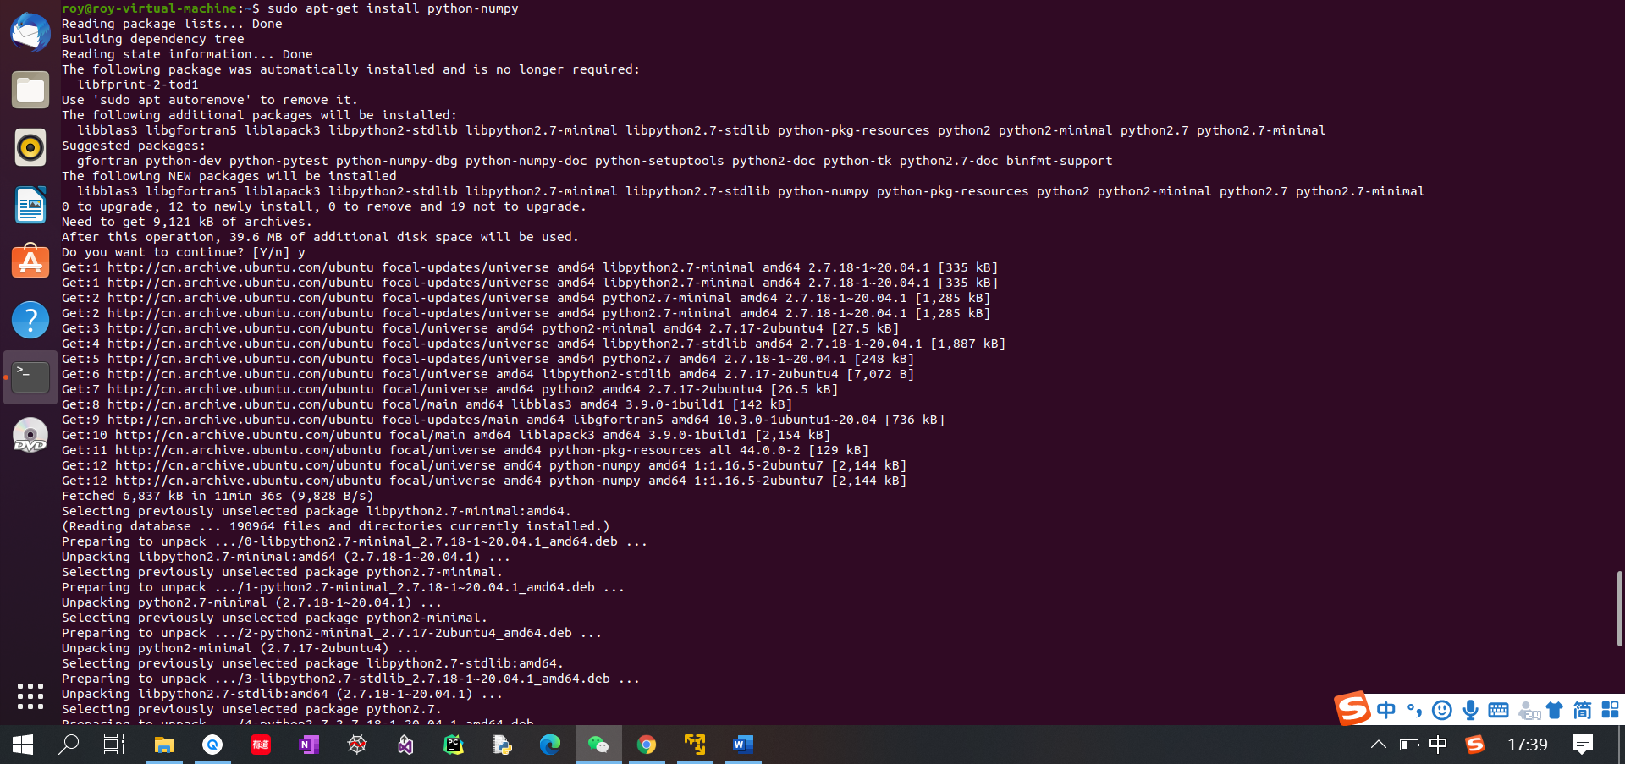

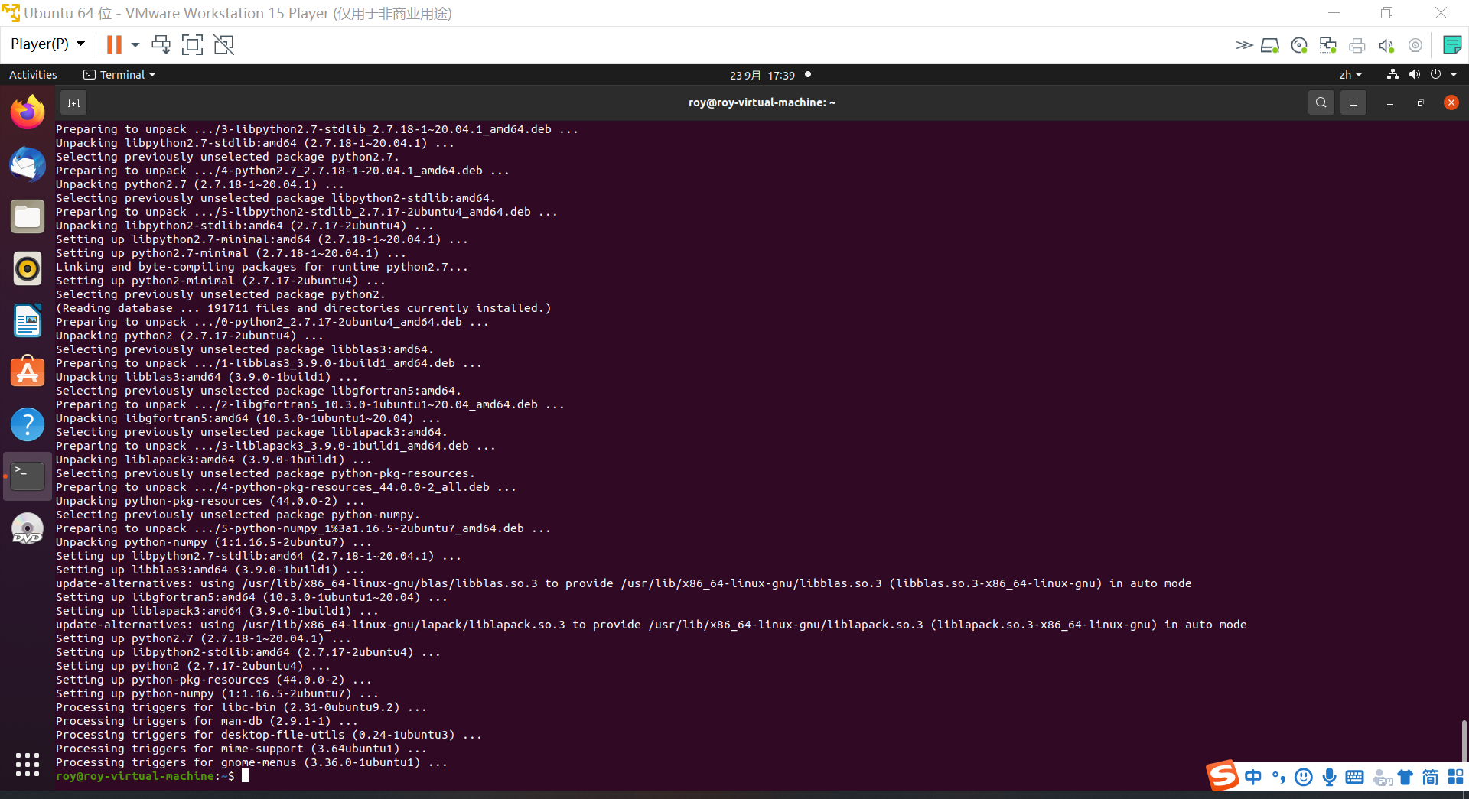

**Command: sudo ape-get install python-numpy, install numpy package for Python in a controller mode**

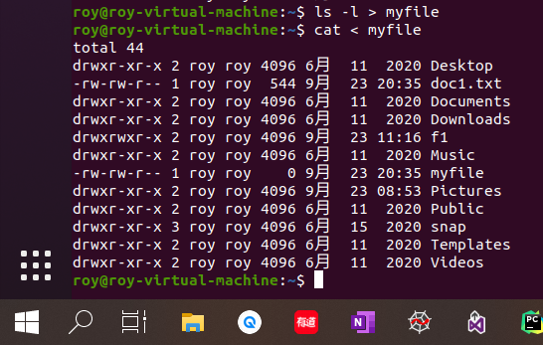

**Command：ls -l > myfile, cat < myfile; Use named pipes to redirect the output of ls -l to a file named “myfile”, and redirect the input from the keyboard to the file contents.**

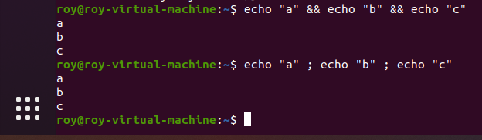

**Command: &&, ； Execute multiple command in one line.**